Attention Students!
Now is your chance to redeem your homework grade!
Due: This Friday, 9/29

If your grade is not as good as you would like it to be, you can complete this assignment to replace up to 2 of your homework grades that were below a 75%.

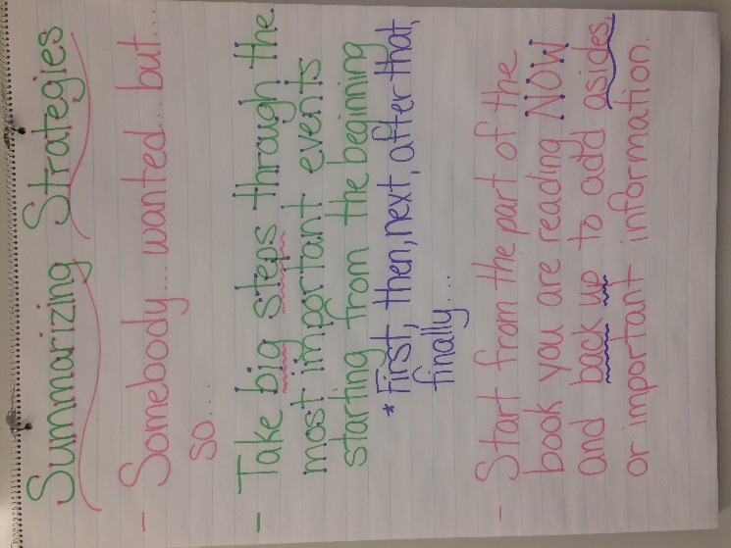
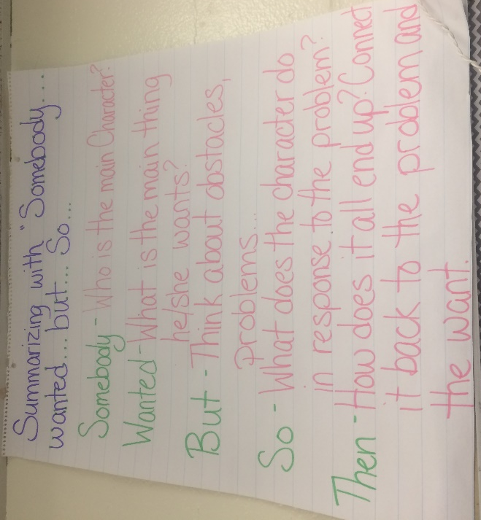
After reading, summarize what you read using one of the strategies you learned in class on a separate piece of paper.

Remember to:
1) Write your name at the top of your paper.
2) Write the title and author of your book at the top of your paper.
3) Include only the most important parts of the story in your summary.
4) You may wish to include: Theme, character traits and/or character change in your summary to boost your level!

